**HIGH LEVEL DESIGN**

**FOR**

**Expense Claim Module**

|  |  |  |  |  |
| --- | --- | --- | --- | --- |
| Prepared by/ Modified by | | Role | | Start Date – End Date |
| Prajwal N  Srinidhi L N | | Team Lead  Configuration Manager | | 04 Dec 2018 –  12 Dec 2018 |
| Ashwija Shetty M  Vaishnavi M  Bindu  Jami Sai Bandhavi | | Developing | | 04 Dec 2018 –  12 Dec 2018 |
| Radha Vennapusa | | Designer | | 04 Dec 2018 –  12 Dec 2018 |
| Jeevan R  Muthu Raj. S | | Designer | | 04 Dec 2018 –  12 Dec 2018 |
| Akshay.K | | Designer | | 04 Dec 2018 –  12 Dec 2018 |
| Reviewed by | | Role | | Date of Review |
| Tanmaya and Uma | |  | | 13 Dec 2018 |
| Approved by | | Role | | Date of Approval |
| Vaishali | |  | |  |
| Circulation List | To all the ELTP mentors and the applicable trainee teams | | Version number of the template | V1.0 |
| **Version number of the work product** | V1.0 | | | |

**TABLE OF CONTENTS**

* 1. Introduction..............................................................................................................................1
  2. High Level Architecture.............................................................................................................2
  3. Schema Design..........................................................................................................................3
  4. Reporting...................................................................................................................................4
  5. Risk & Assumptions...................................................................................................................5

References

**1. INTRODUCTION :**

This Document outlines the High Level Design for the PLP “**Expense Claim Module**” for the JEE with Cloud. The project is to claim the employee’s expenses and generate report related to Employee’s Expense Claim Module. This document contains Design of Dimensional model, Schema structure and Report and related high level details.

**2. SCHEMA STRUCTURE:**

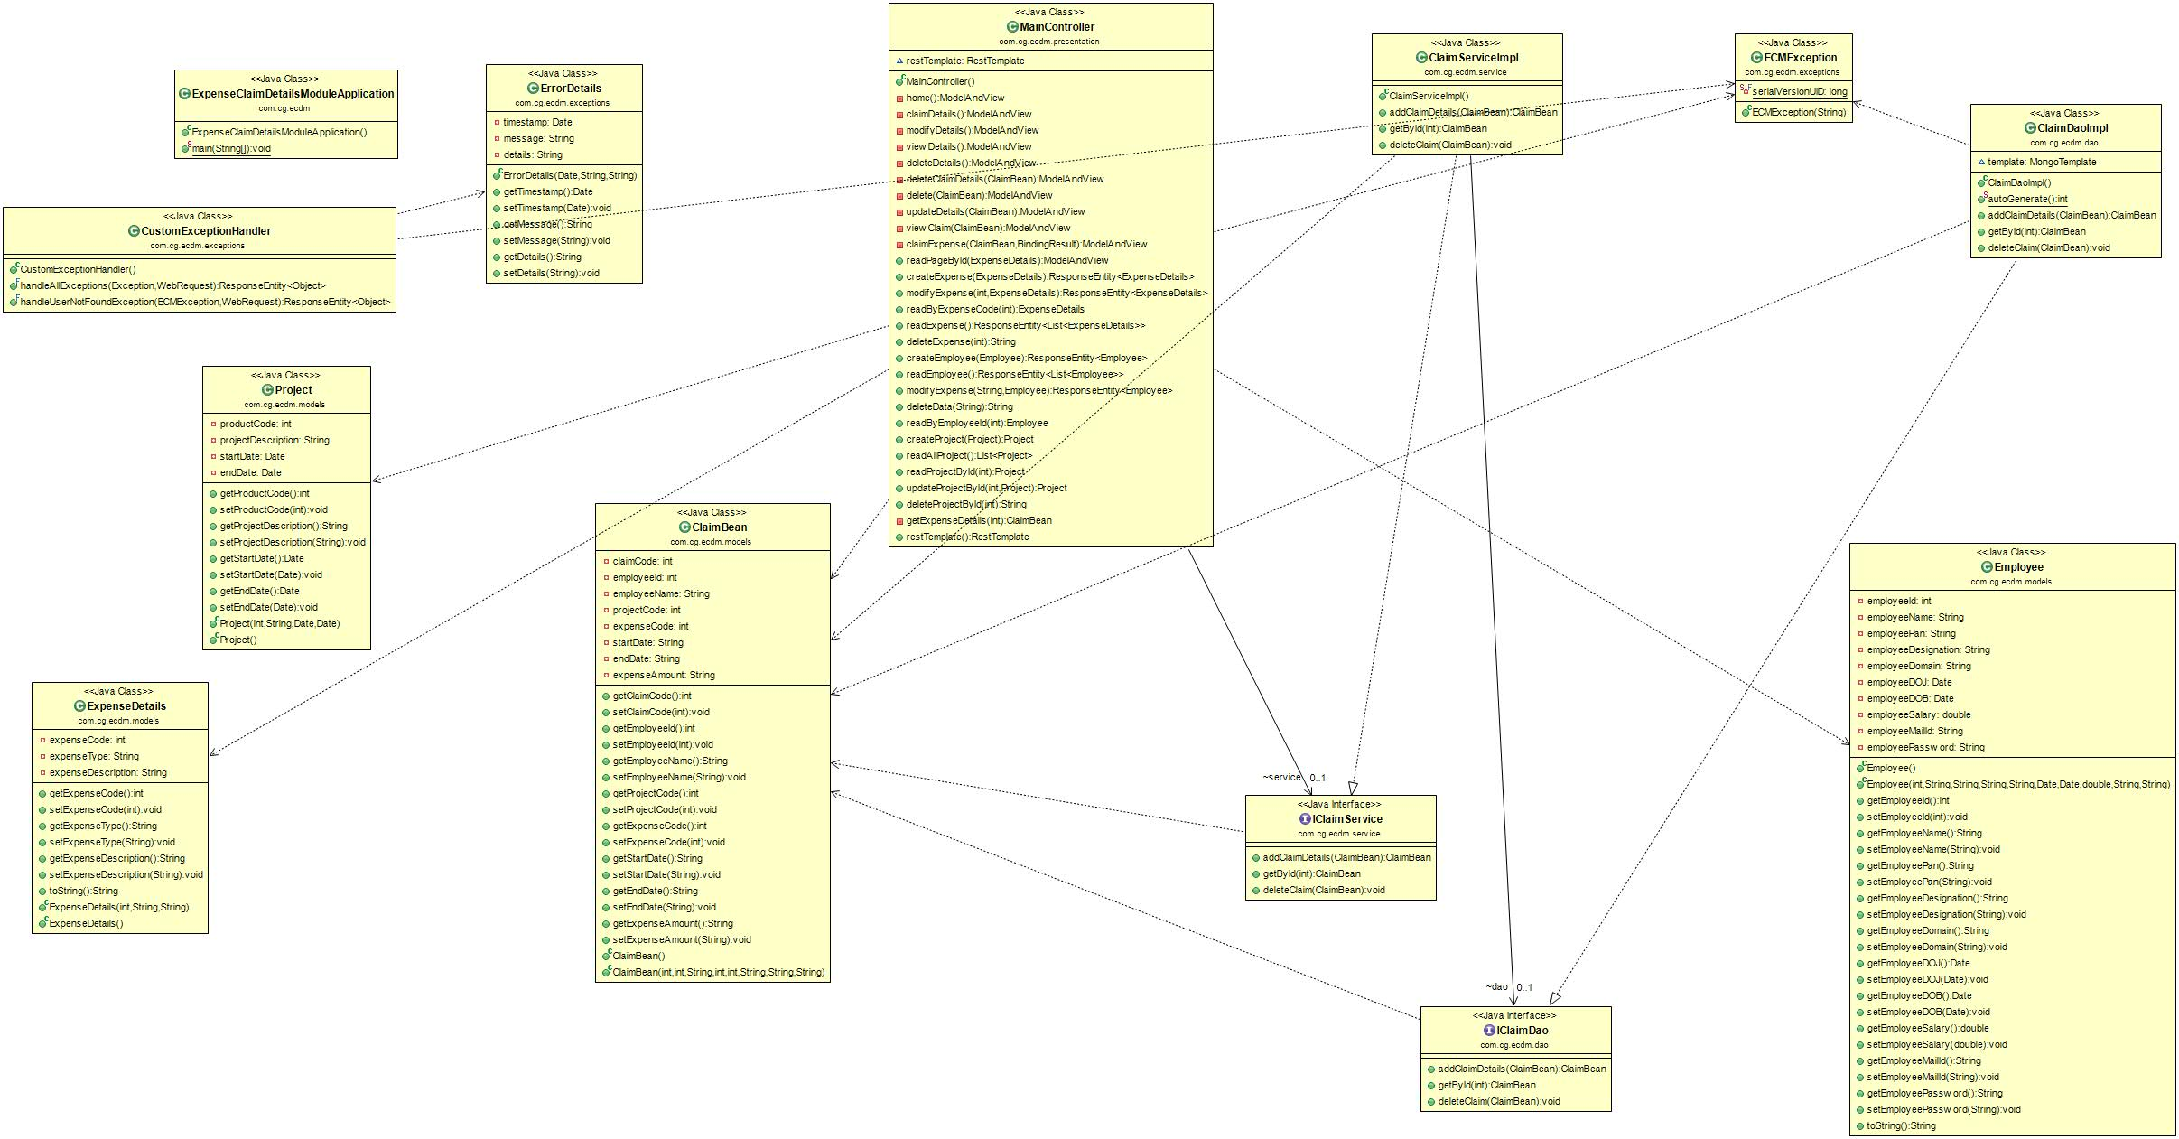

**3. REPORTING:**

1. Inserting the Employee ID

2. Inserting the Expense ID.

3 Inserting the Project ID

4. Fetching the particular Employee’s claim details.

**5. DEPENDENCIES & ASSUMPTION:**

**Dependencies:**

The user can enter the expense details.

**Assumptions:**

User entered expense code details are stored in the database.